23CSE111

OBJECT ORIENTED PROGRAMMING

LAB MANUAL 

**Department of Computer and Science Engineering Amrita**

**School of Engineering**

**Amrita Vishwa Vidyapeetham, Amaravati Campus**

NAME:- C.Umesh Chandra Reddy.

ROLL.NO:-av.sc.u4cse24037

VERIFIED BY:-

|  |  |  |  |  |
| --- | --- | --- | --- | --- |
| S.NO | Programs | DATE | PG.NO | SIGNATURE |
| WEEK-1 |  | 27-01-2025 |  |  |
| 1. | Write the steps to download  and install Java. |  | 3 |  |
| 2. | Write a java program to print the message“Welcome to java programming”. |  | 6 |  |
| 3. | Write a java program that prints name, roll number and section of a student. |  | 7 |  |
|  |  |  |  |  |
|  |  |  |  |  |

WEEK:-1

1. Write the steps to download and install Java.

**Aim:** To download and install java.

**Procedure:**

i. Visit oracle.com website to download Java

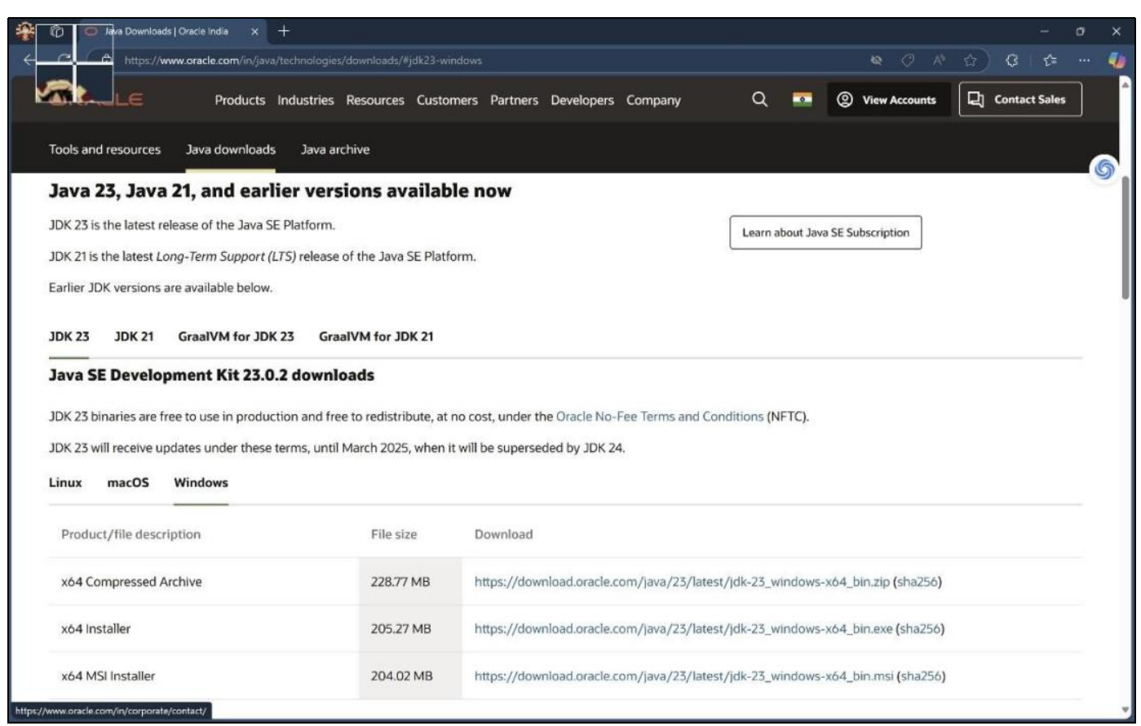

ii. Download the version which supports LTS (JDK 21) x64 installer for windows.

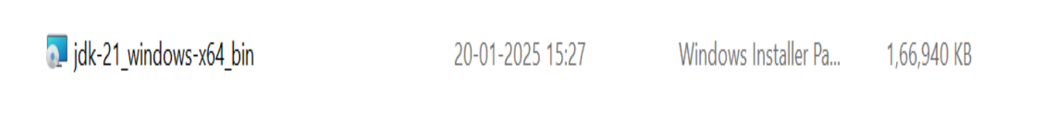

iii. Install and copy the path.

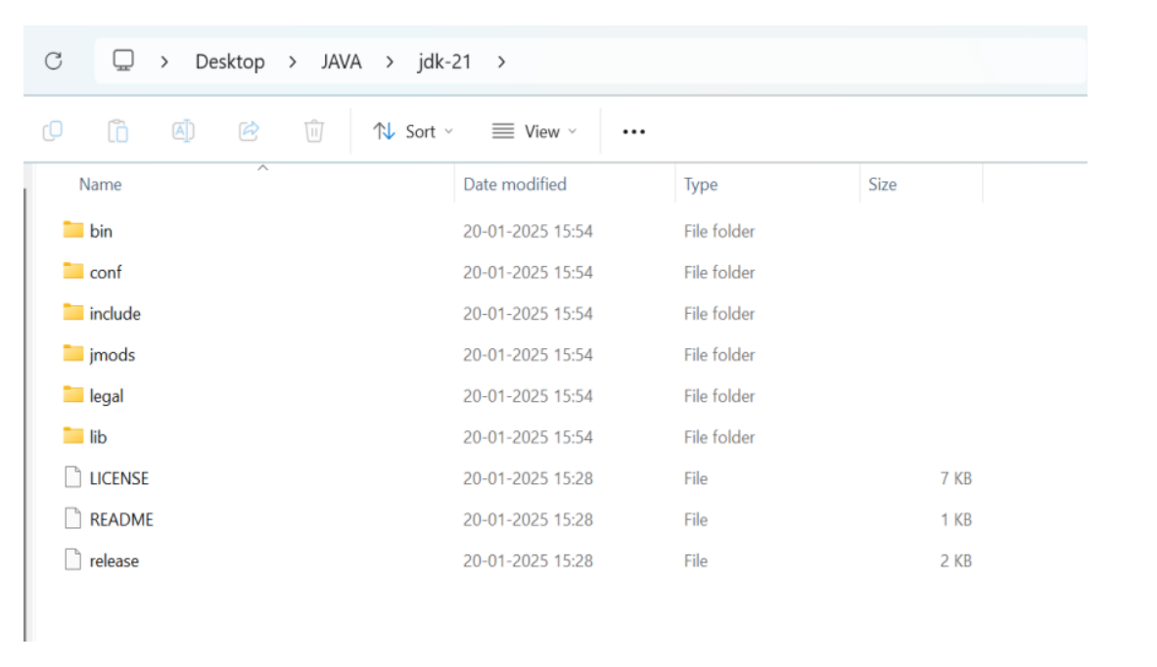

iv. Open environmental variables and add a new file with path.

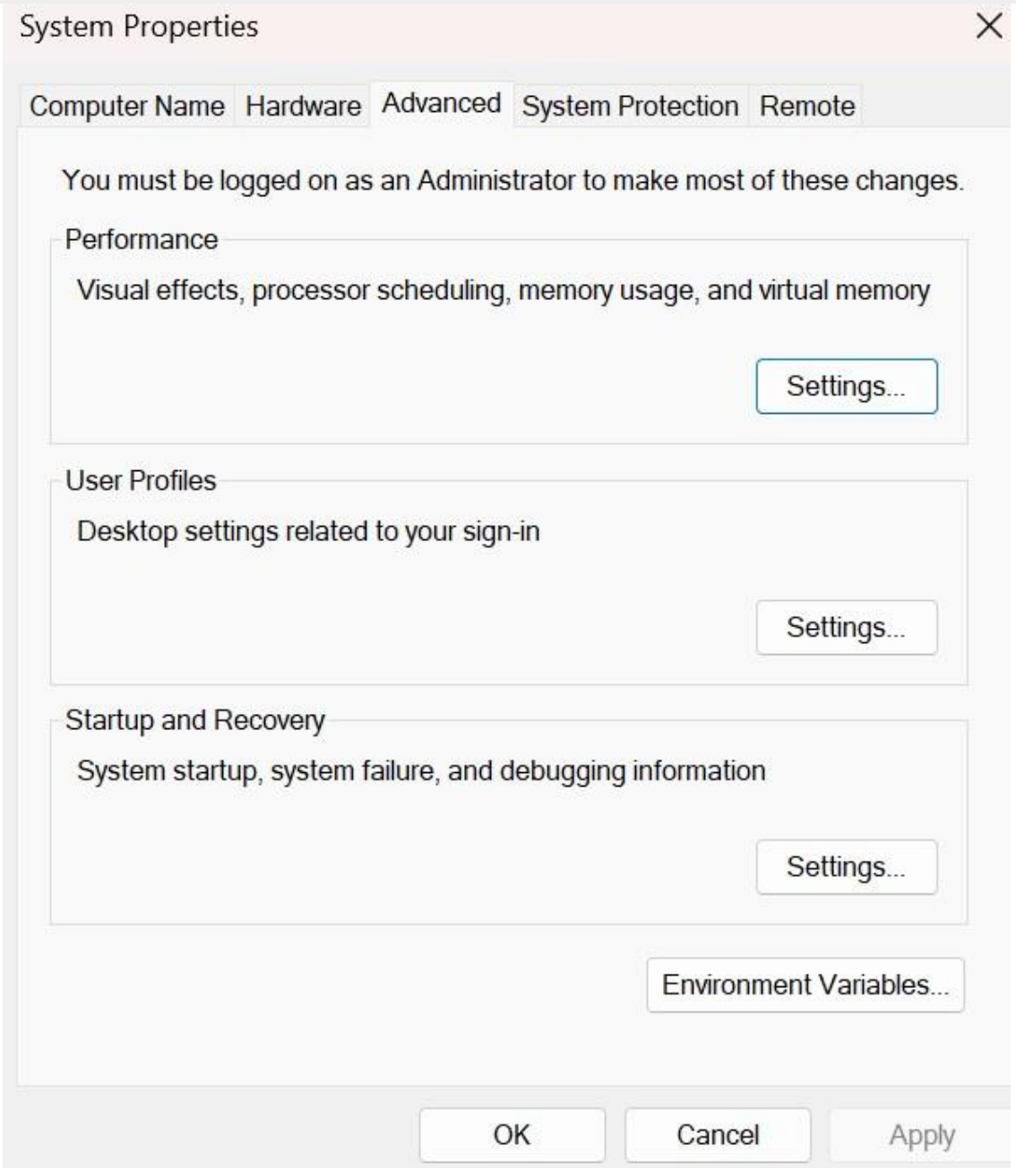

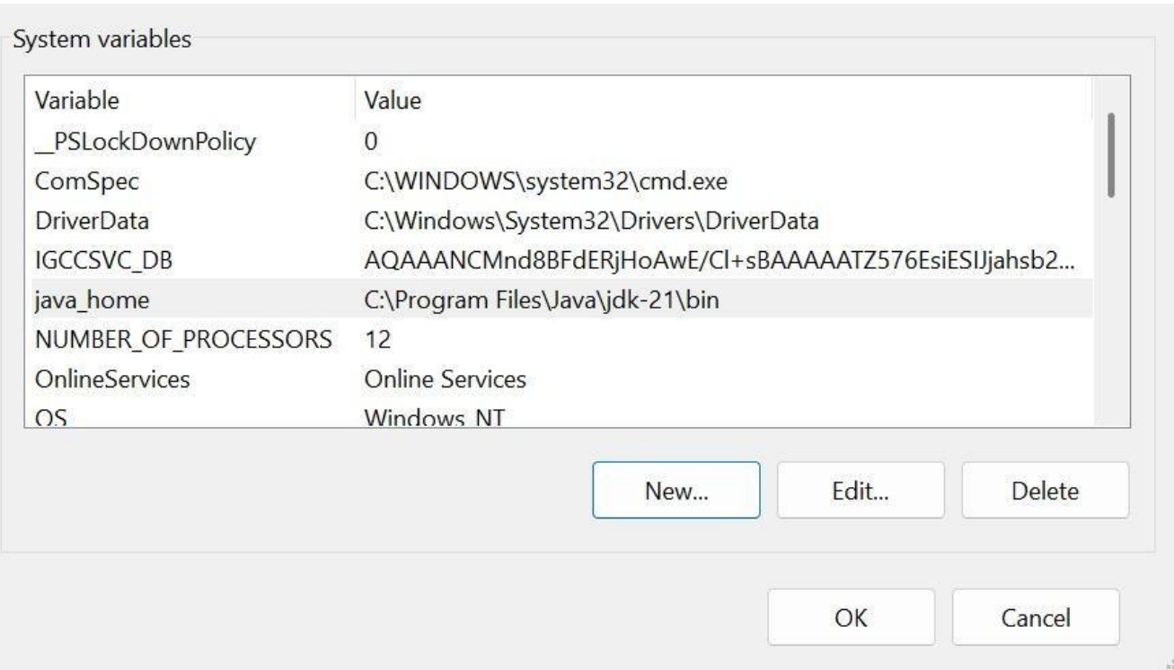

v. Verify java version in command window.

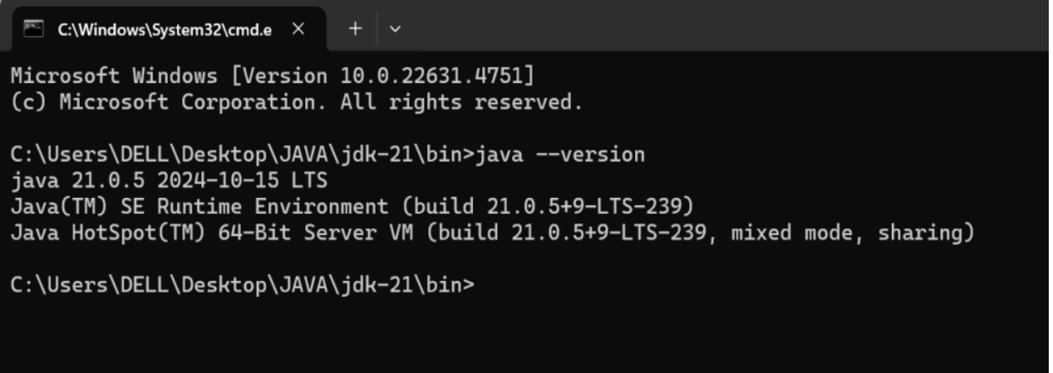

2. Write a java program to print the message “Welcome to java programming”.

CODE:

class ex1

{

public static void main(String[] args)

{

System.out.println("Welcome to java programming.");

}

}

OUTPUT:-

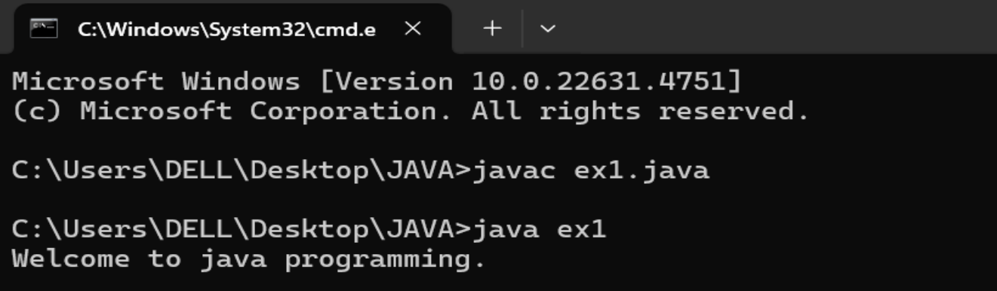

ERROR:-

|  |  |  |
| --- | --- | --- |
| S.NO | EXPECTED ERROR | REASON |
| 1. | ; | ; is expected at end |
| 2. | S | Capital S is expected for  String and System. |

3.Write a java program to print the name, roll number and section of a student.

**Code:**

class ex2

{

public static void main(String[] args)

{

String name = "Umesh";

int rollNo = 24037;

String section = "A";

System.out.println("Student Information:");

System.out.println("Name:" + name);

System.out.println("Roll No:" + rollNo); 7

System.out.println("Section:" + section);

}

}

**Output:**

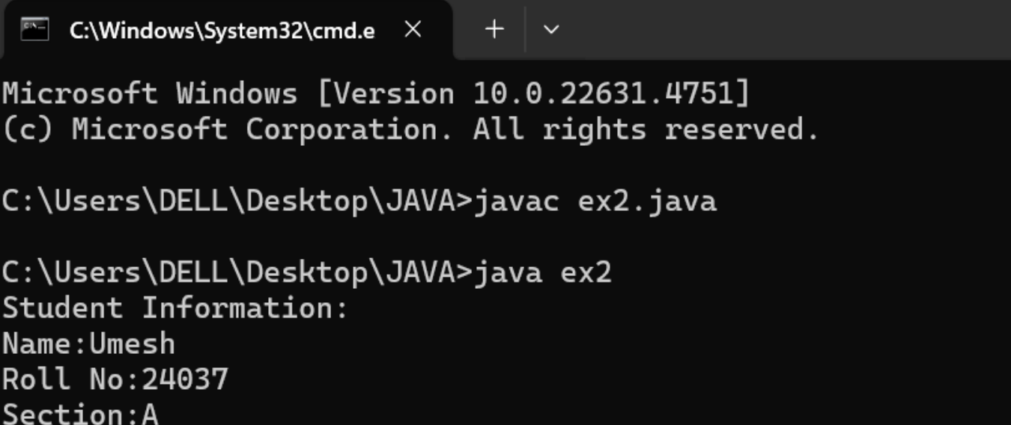

ERROR:-

|  |  |  |
| --- | --- | --- |
| S.No | EXPECTED ERROR | REASON |
| 1. | S | Capital S is expected for  String and System. |